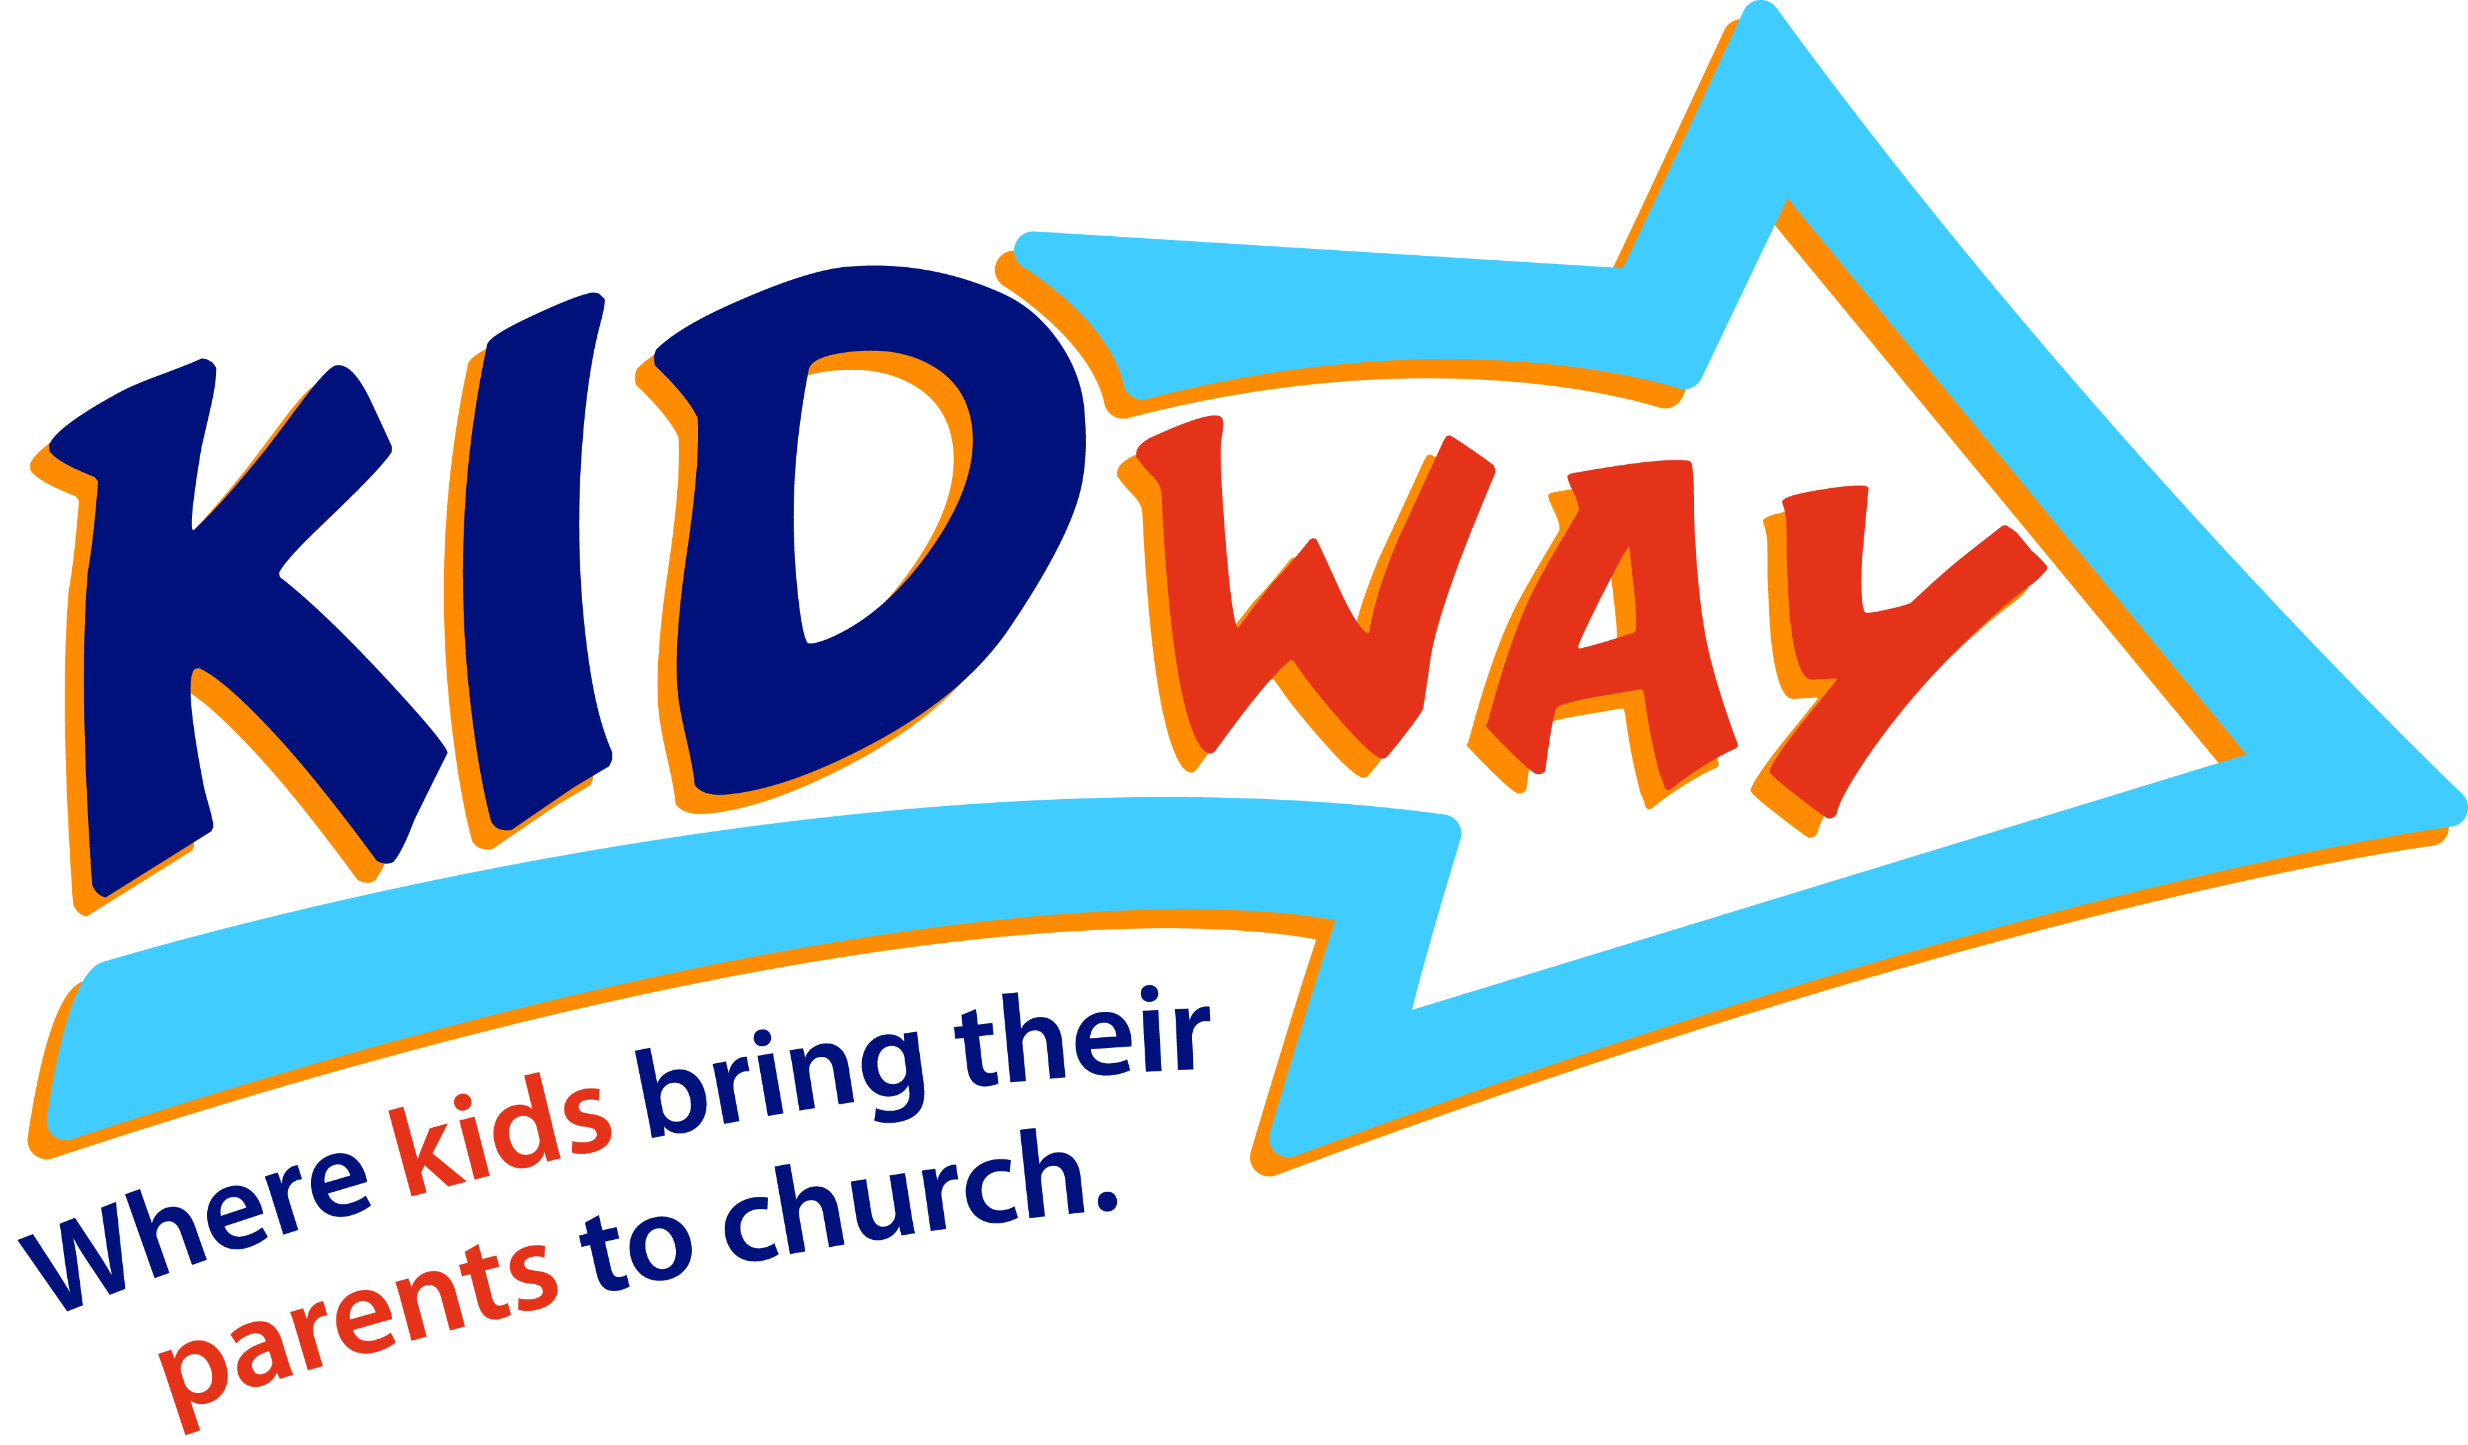
2015/2016
Service & Rehearsal Times

September 7 (Kidway Stage at Family Palooza)
September 12/13
Rehearsal: Tuesday, August 27 6:30p-8:00p FH2

October 3/4
Rehearsal: Tuesday, September 29 6:30p-8:00p FH2

November 7/8
Rehearsal: Tuesday, November 3 6:30p-8:00p Warehouse

December 5/6
Rehearsal: Tuesday, December 1 6:30p-8:00p FH2

January 9/10
Rehearsal: Tuesday, January 5 6:30p-8:00p FH2

February 6/7
Rehearsal: Tuesday, February 2 6:30p-8:00p FH2

March 5/6
Rehearsal: Tuesday, March 1 6:30p-8:00p Warehouse

April 2/3
Rehearsal: Tuesday, March 29 6:30p-8:00p FH2

May 7/8
Rehearsal: Tuesday, May 2 6:30p-8:00p FH2
Kidway Cast Picture will be taken at this rehearsal

Contact Info

Misty Yates
253-8811
myates@secc.org

Amy Henson
253-8819
ahenson@secc.org

Service Times & Dress Rehearsals

Saturday
Full Dress Rehearsal: 5:00pm
Service: 6:30 pm

Sunday
Full Dress Rehearsal 9:00am
Service: 10:30 am

Full Dress Rehearsal 11:45 am
Service: 12:45 am

